**AFRITECH ELECTRONIC LTD. CASE STUDY**

**PROJECT REPORT**

**INTRODUCTION**

Afritech Electronics Ltd. stands out as a prominent player in the global consumer electronics sector, particularly renowned for its innovative offerings in smartphones, tablets, and wearable technology. The company is headquartered in the United States and has been growing steadily, now boasting a workforce of 200 dedicated employees. In the fiscal year 2022, AfriTech Electronics achieved an impressive annual revenue of $2 million.  
  
This achievement is a testament to the company's unwavering commitment to quality and its focus on integrating cutting-edge technology into its products. Such dedication has not only helped AfriTech Electronics carve a niche for itself in the competitive electronics market but has also garnered it a reputation as a reliable and trusted brand among consumers worldwide. The company's strategic focus on key technological trends and commitment to excellence positions it for continued success and influence in the international electronics industry.  
   
AfriTech Electronics Ltd. has been facing a growing challenge related to its brand reputation. In recent years, the company has encountered several issues such as negative customer reviews, product recalls, and public relations crises. These issues have led to a decline in customer trust and have affected sales and market share.

**BUSINESS PROBLEMS**

 1. The company is experiencing a surge in negative social media conversations about its products and customer service. These conversations are damaging its brand image.  
2. Complaints related to product defects, delays in customer support response, and billing issues have been rising, leading to a drop in customer satisfaction.  
3. Recent product recalls have received significant media attention, causing panic among customers and stakeholders.  
4. Rivals are gaining market share by exploiting AfriTech Electronics Ltd.’s reputation challenges.

**OBJECTIVES**

The primary objectives of this project are as follows:  
1. Maintaining positive brand reputation is vital to retaining market share and fending off competition.  
2. Improving customer satisfaction and addressing concerns promptly can reduce customer churn.  
3. Effective monitoring can help identify and address potential crises before they escalate.  
4. Social media monitoring tools provide valuable insights into customer sentiment, enabling data-driven decision-making.  
5. Consistent messaging and understanding customer preferences can lead to more effective marketing campaigns.  
  
Brand reputation is a critical asset in the consumer electronics industry, and social media plays a pivotal role in shaping influencing public perception. The significance of initiating this project lies in addressing the following key reasons:  
1. Continuously monitor social media platforms for mentions of the company and its products.  
2. Analyze sentiment in social media conversations to identify positive and negative trends.  
3. Identify and prioritize customer complaints and issues for swift resolution.  
4. Implement early warning systems to detect potential crises and take proactive measures

**DATA ANALYSIS PROCESS**

**PREPARE PHASE:** The data to be used for this project is gotten from the company database system. For the purposes of this case study, the datasets are appropriate and will enable us to find solution to the business problems. A snippet of how the data is organised is shown below

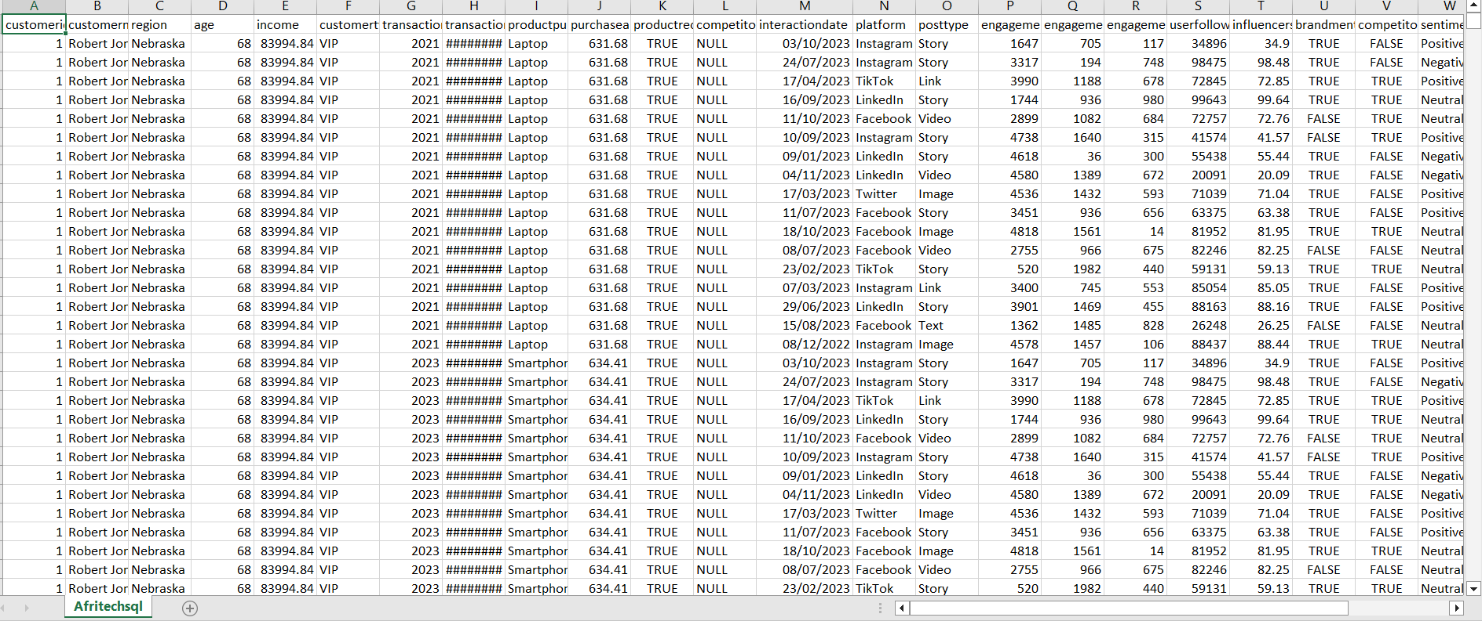

**PROCESS PHASE**

The following steps were taken to process the data

1. Download the data from the company database
2. Unzip the files
3. Create a folder on desktop to house the files. Use appropriate file-naming conventions.
4. Create subfolders for the .csv file and the .xlsx or Sheets file so that original copy of data is available. Move the downloaded files to the appropriate subfolder.

**In SQL**

1. As soon as the dataset was cleaned in excel, it was moved to Progresql for data normalisation. The dataset is made up of 27 headers or field and the need for normalisation is of essence so as to minimise the number of headers
2. Tables were created and populated accordingly
3. PostgreSQL was opened , connected to server , database(AFRITECH_DB) was created .See below

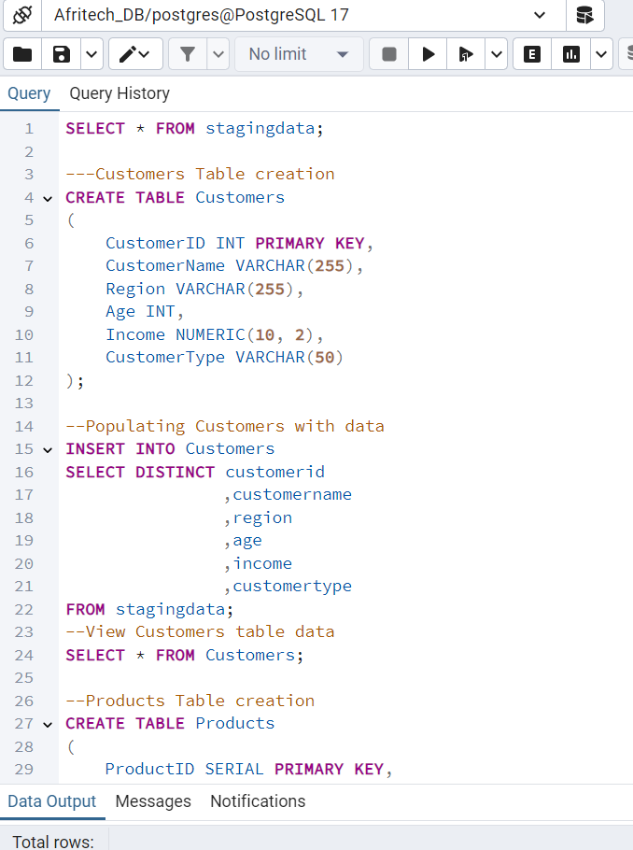

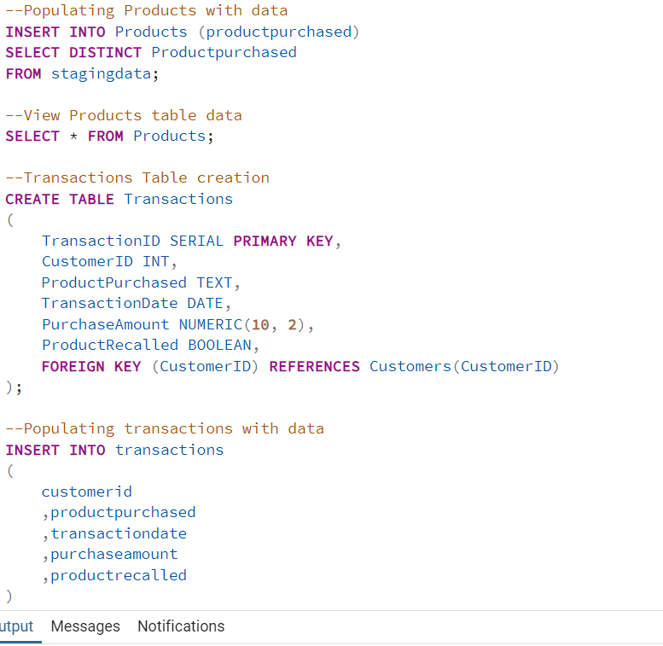

A stagingdata was restored for the purpose of data normalisation. A snippet of the merged data is shown below:

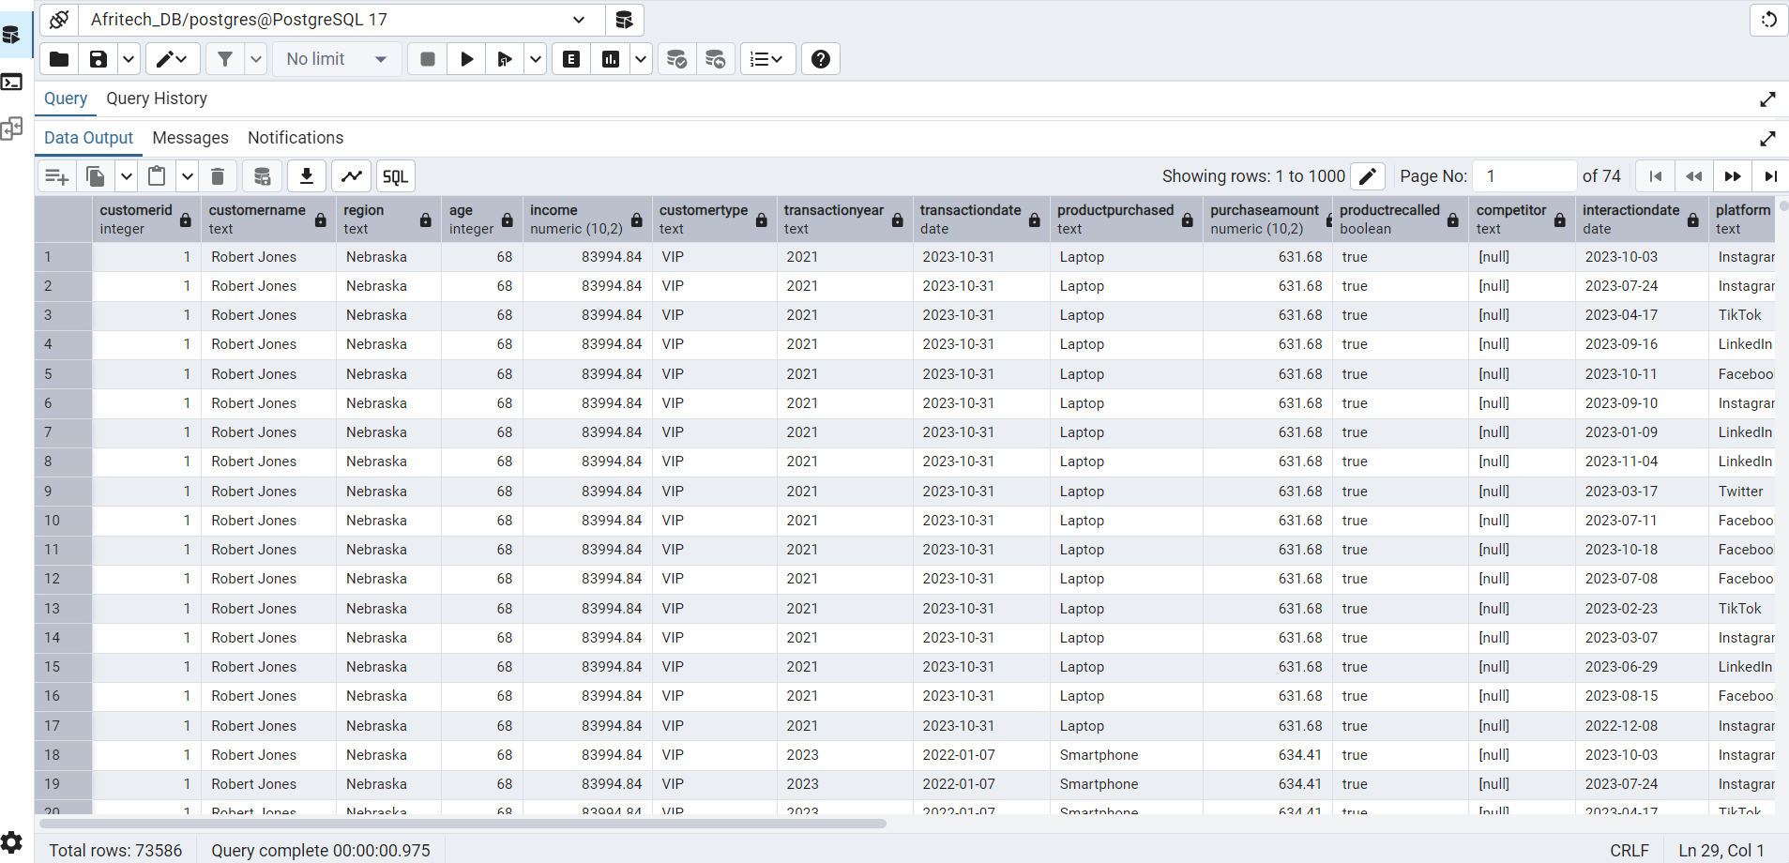

To obtain the stagingdata, the step below was done

SELECT *

FROM Stagingdata

1. The stagingdata was further split into 8 tables which are: customers, products ,crisisid, platform ,transactions, posttype, sentiment and social media

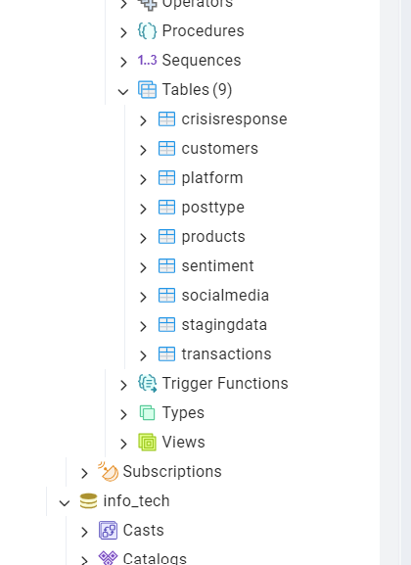

1. As soon as that was done , I exported it to power BI for visualisation

**SHARE PHASE**

After analyzing the data, A visualization is made to support and present key findings. The visualization below shows visuals highlighting the different key areas.

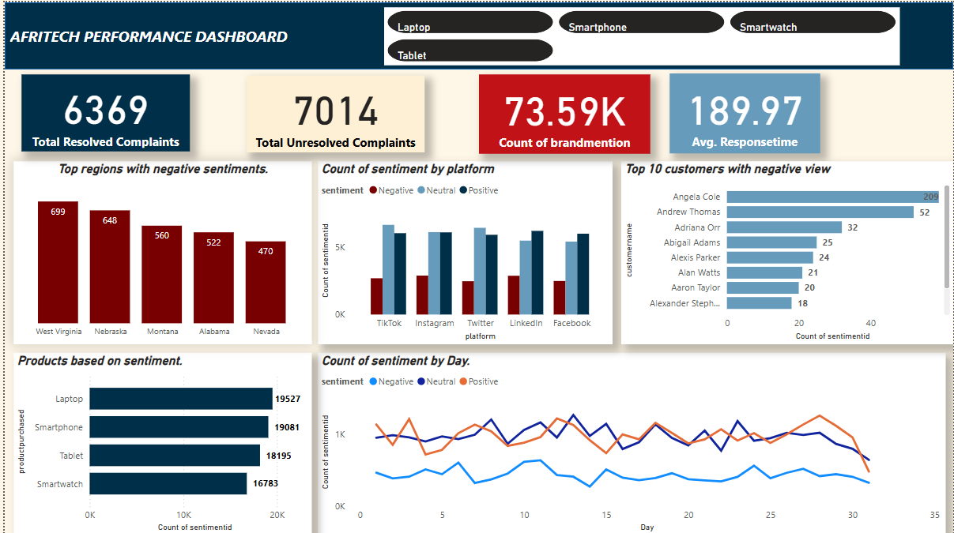

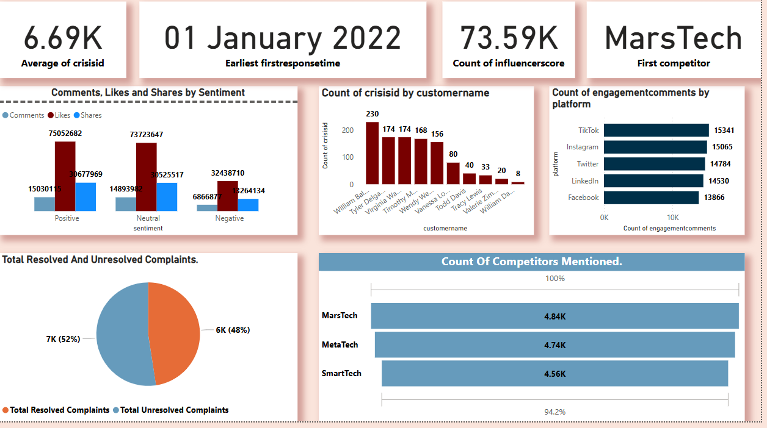

**INSIGHTS AND RECOMMENDATIONS**

Below are the insights generated from the analysis

